Data Quality:
The source data was already very clean with data available daily, monthly, or quarterly, depending on the variable:
- S&P500 Index (GSPC):
  - The market: leading indicator for investor sentiment
  - DAILY DATA from 1970: 14,155 rows, 14,155 non-null
- CBOE Volatility Index (VIXCLS):
  - The "Fear Gauge": measures market stress/uncertainty
  - DAILY DATA from 1990: 9,428 rows, 9,127 non-null
- 10-Year Treasury Rate (DGS10)
  - Growth Expectations: benchmarks long-term borrowing costs
  - DAILY DATA from 1970: 14,646 rows, 14,023 non-null
- Consumer Price Index (CPIAUCSL)
  - Inflation: tracks the purchasing power of the Dollar
  - MONTHLY DATA from 1970: 673 rows, 672 non-null
- Effective Federal Funds Rate (FEDFUNDS)
  - Monetary Policy: the interest rate set by the Federal Reserve
  - MONTHLY DATA from 1970: 673 rows, 673 non-null
- Unemployment Rate (UNRATE)
  - Labor Market: lagging indicator of economic health
  - MONTHLY DATA from 1970: 673 rows, 672 non-null
- Gross Domestic Product (GDP)
  - The "Scorecard": total value of goods/services produced
  - QUARTERLY DATA from 1970: 224 rows, 224 non-null
- Individual stock tickers:
  - DAILY DATA from 1970: 14,155 rows, various non-null (depending on time of listing of stock)
Values were missing only for days when markets were closed, or when stocks have not yet been listed.
A ‘df_master’ dataframe was created with every single calendar day as a row, then all data sources were merged into this df_master; this ensured that no information was lost due to various sampling frequencies.
Since GDP data was only available on a quarterly basis, all the rest of the data had to be resampled to quarterly frequency in order to conduct broader economic analysis

Feature Engineering:
New columns had to be added to the dataframe in order to work with the data:
- Recession Indicator:
  - No (0) / Yes (1)
  - Applied Sahm Rule: 3-month moving average of Unemployment Rate rises by 0.5%+ above its 12-month low
- Economic Output Gap:
  - Represents percentage deviation of actual economy from its long-term sustainable trend
  - Applied Hodrick-Prescott (HP) Filter to separate GDP (log scale) time series into long-term trend vs cyclical component to determine 'Output Gap'
  - Positive Output Gap: economy is 'overheating' (actual GDP higher than long-term trend)
    - Interpretation: high demand, factories are running at max capacity, labor market is likely tight (low UNRATE)
    - Risk: typically leads to rising inflation (CPIAUCSL)
  - Negative Output Gap: 'slack' in the economy (actual GDP below its potential)
    - Interpretation: economy is underperforming, factories are idle, and unemployment (UNRATE) is usually rising
    - Deep negative values are almost always associated with Recessions
  - Slope of Output Gap: indicates business cycle

S&P500 vs Economic Output Gap:
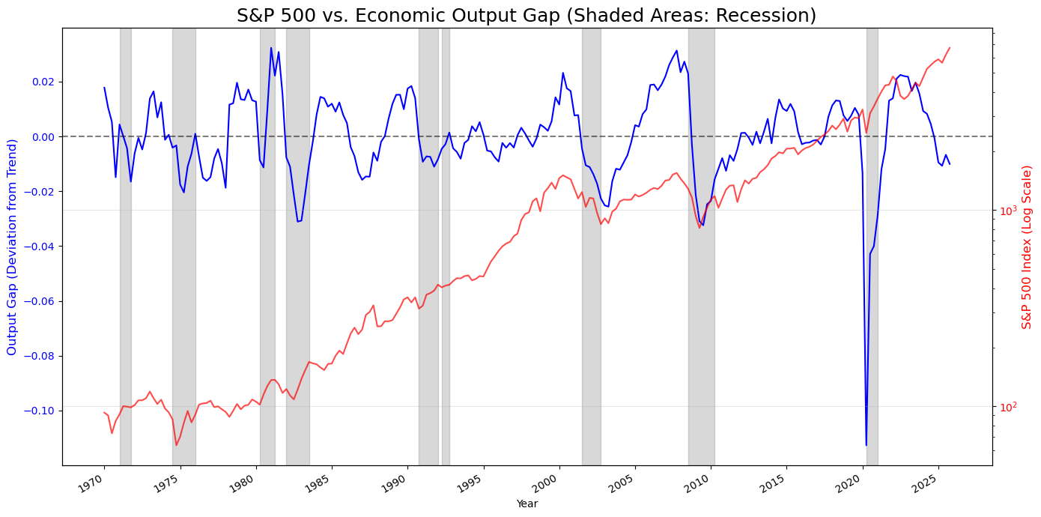
- Leading Indicator: S&P500 prices in economic downturns & recoveries months before GDP reflects them
- For example, 2008 financial crisis:
  - S&P500 started declining in late 2007, while Output Gap was still positive / economy still overheating for several months before finally turning negative)
  - S&P500 started increasing in 2009, while Output Gap was still very negative
- 2020 Shock Event (COVID-19): the drop in Output Gap was much more extreme (size & velocity) than during other economic cycles (output gap widened gradually). The S&P500 followed instantly, but also recovered at a record pace. During shock events the leading nature of the market is compressed into weeks / days rather than quarters.
- Negative Output Gap: economy is performing below potential
  - When S&P500 increasing while Output Gap still negative, investors are anticipating recovery before it actually shows up in GDP data.
- Positive Output Gap: economy is overheating
  - When S&P500 flattens / drops while Output Gap still positive, the Federal Reserve will raise interest rates to cool the economy (bad for stock prices)
- Current Trends: Output Gap currently in negative territory; despite high stock prices, the real economy is performing slightly (~1%) below its calculated potential
- Recession Bars: economic context for S&P500 vs Output Gap
  - Recession Defined by Sahm Rule: 3-month moving average of Unemployment Rate rises by 0.5%+ above its 12-month low
  - Economic Troughs: Output Gaps' lowest points usually during recessions (inside gray shaded areas)
  - Stock Market Recoveries: S&P500 usually starts to recover before recessions (gray shaded areas) end, pricing in eventual recovery

S&P500 vs Yield Curve (Yield Spread):
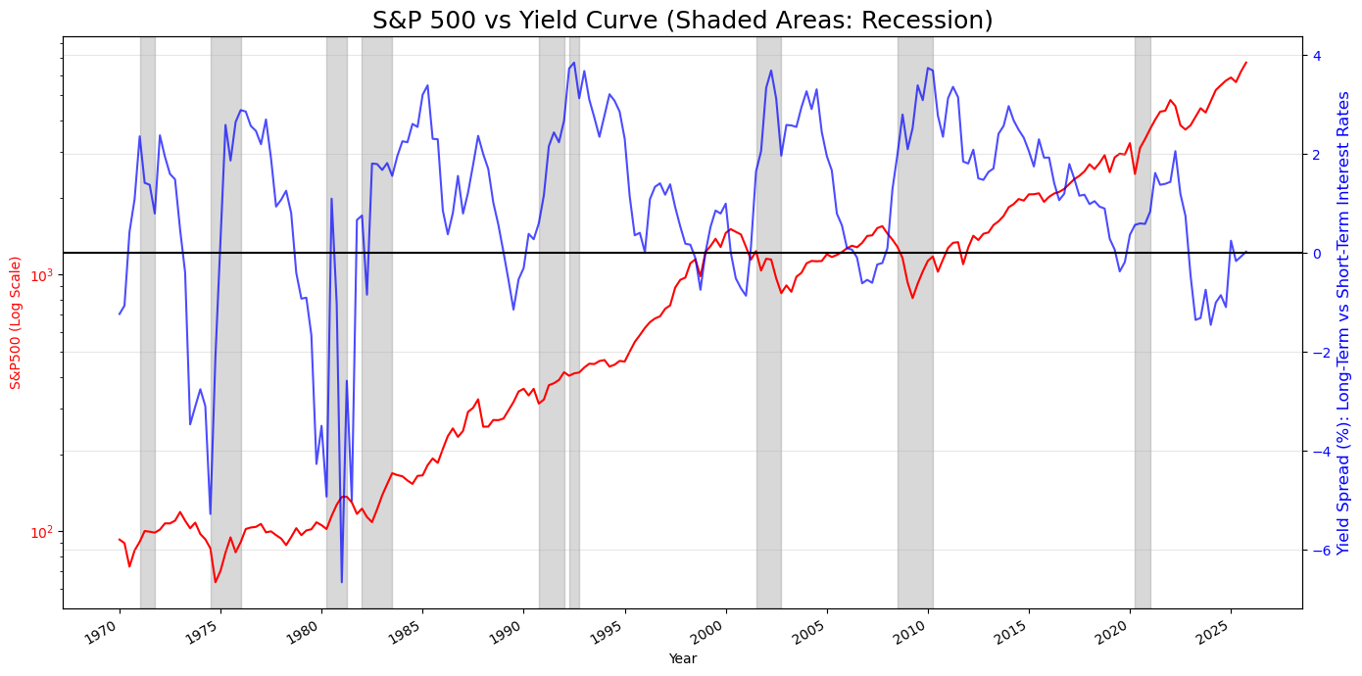
- Yield Curve (Yield Spread): Long-Term Interest Rate (DGS10: 10-Year Treasury Rate) vs Short-Term Interest Rate (FEDFUNDS: Federal Funds Rate)
- Yield Curve inversion occurs when short-term rates (FEDFUNDS: Federal Funds Rate) are higher than long-term rates (DGS10: 10-Year Treasury Rate)
- Yield Curve inversions (negative Yield Spread) are lead indicators of upcoming recessions:
  - Normal Yield Curve (Positive Spread): Investors demand higher returns for locking in their money for longer periods; this signals a healthy, growing economy
  - Inverted Yield Curve (Negative Spread): Investors are worried about the future, so they are willing to accept lower yields for longer-term bonds just to safely park their cash. It also indicates that the Federal Reserve has raised short-term interest rates aggressively to fight inflation.
- The S&P500 follows the Yield Curve on a few month lag before recessions start
- The S&P500 often crashes after the Yield Curve starts to increase again, as the Fed panic cuts short-term interest rates as the economy begins to break

Recession Probability Model:
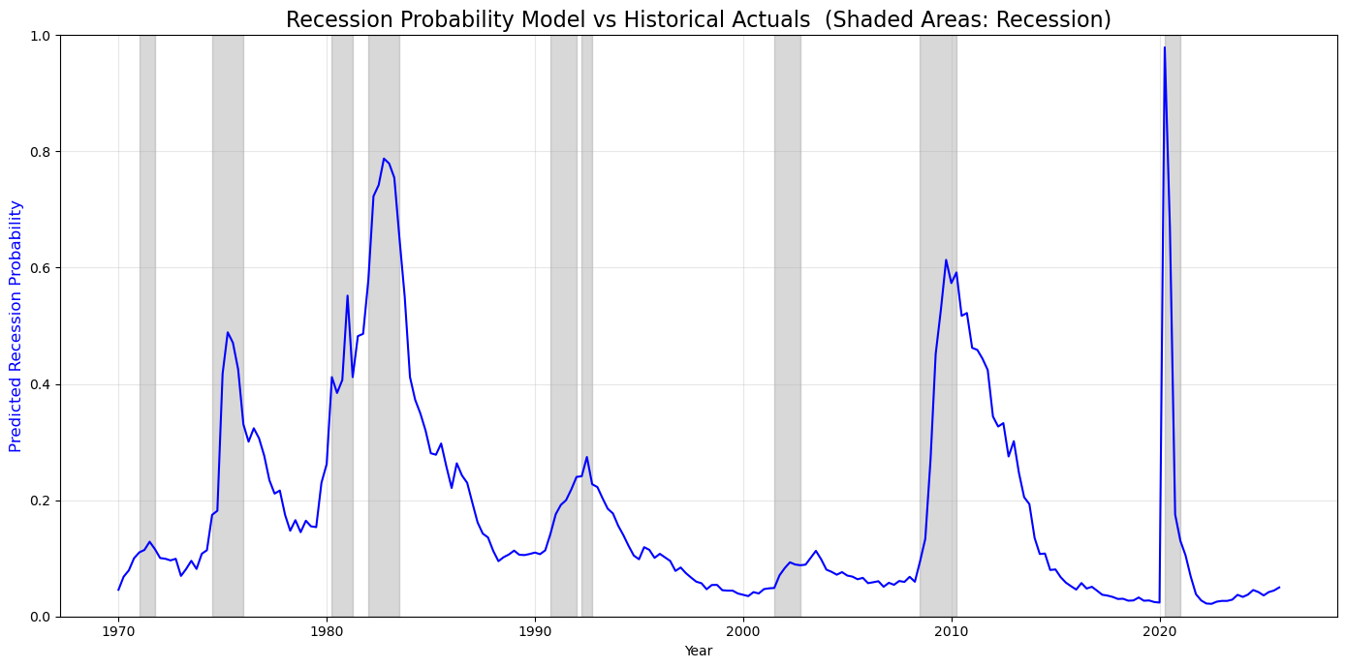
- Used Logistic Regression to develop Recession Probability Model:
  - Dependent Variable: Recession Indicator (engineered binary variable based on Sahm rule)
  - Independent Variables:
    - Yield Spread: often goes negative / inverts before a recession
    - Unemployment Rate (UNRATE): spikes during economic contractions
    - Fed Funds Rate (FEDFUNDS): high rates can cool the economy too much, leading to recession
- The Recession Probability Model:
-1.87 - 0.08 Yield Spread + 1.2 Unemployment Rate + 0.21 Fed Funds Rate
- As seen from the graph above, the model is fairly good at predicting recessions.
- Unemployment Rate: most significant predictor; a sharp rise in the unemployment rate is the most reliable sign that a recession is fast approaching
- Yield Curve: leading indicator, as it often inverts (as seen above) months before a recession
- Fed Fund Rate: when the Federal Reserve raises rates to combat inflation during expansions / peaks, it often leads to contraction / recession

Sector Sensitivity:
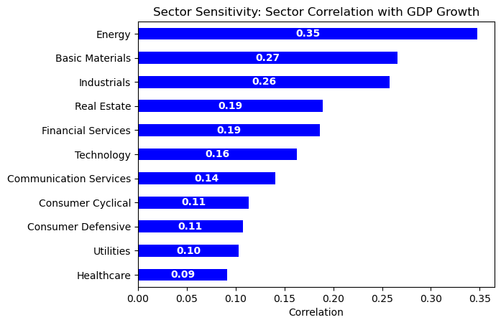
- Average sector returns correlation with GDP growth
- Cyclical Industries: Energy, Basic Materials, and Industrials are most correlated with GDP Growth (35%, 27%, and 26% respectively)
- Defensive Industries: Healthcare and Utilities are least correlated with GDP Growth (9% and 10% respectively)
- As an investment strategy:
  - Early recovery / economic expansion: move investments into highly cyclical industries
  - Late expansion / peaks: move investments from market into safe havens (defensive industries are still positively correlated with GDP growth)

